PreclinicalEEGFramework Validation

data source: http://physionet.incor.usp.br/physiobank/database/sleep-edf/
SC4102e0.rec as edf
4/18/1989 3:56 PM
4/19/1989 3:45 PM
23h 49m

NSB EDF Reader.
- fixed error in read. only reading the 1st data record
- fixed subtract out mean
- validated 21Feb2012 as the same read as NeuroScore and Spike2

data source: Maccine
3747
2/9/2012 3:15 AM
2/10/2012 3:00 AM

NSB DSI Reader

Load SC4102e0.rec as edf into NeuroScore 2.1
data source http://physionet.incor.usp.br/physiobank/database/sleep-edf/
Used Spectrum Export Wizard
Fpz-Cz

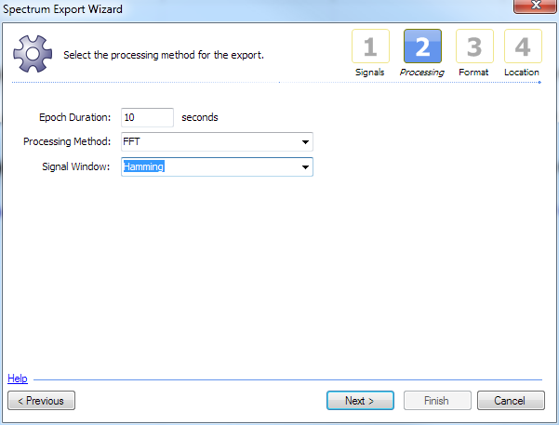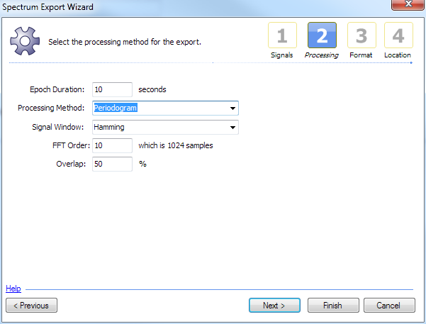
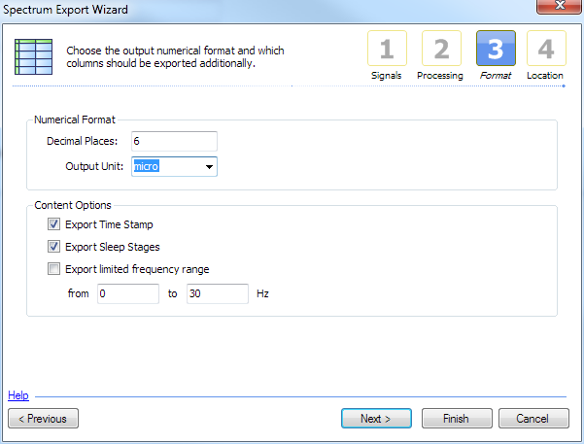

CED using waterfall script
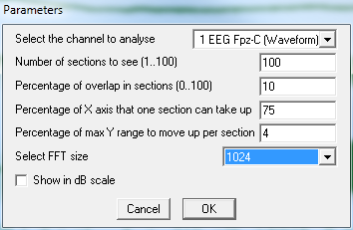
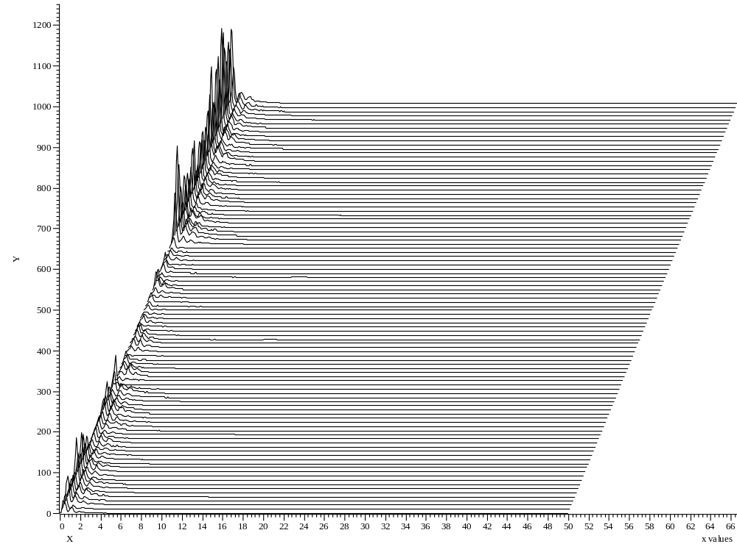

Sleep Scoring Rodent
